|  |
| --- |
| **Applied Cryptography Lab**  Week – 9  Date : 27-11-2022 |
| Name : J Chethana Datta  SRN : PES2UG20CS148 |

**Lab Setup:**

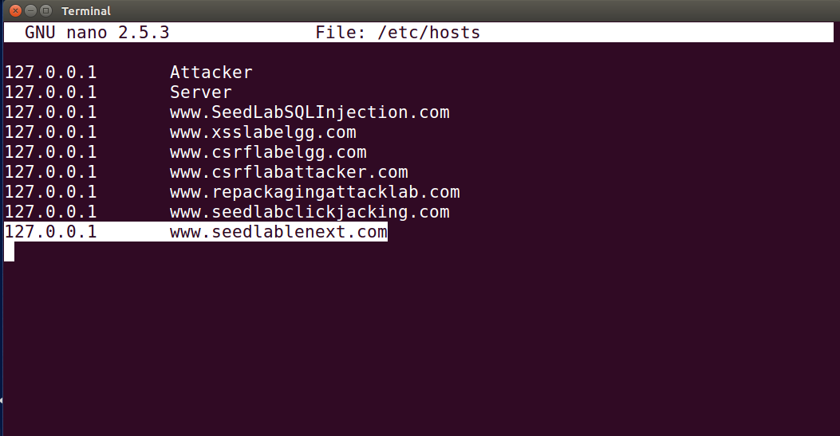

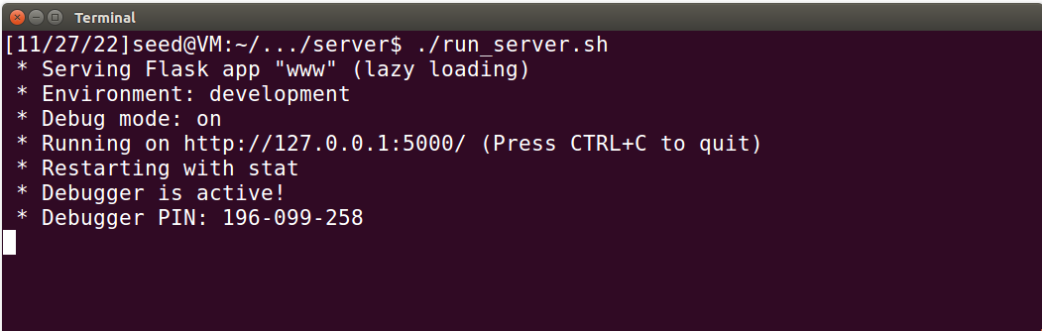

TASK-1 Send request to list files

Calculating the MAC:

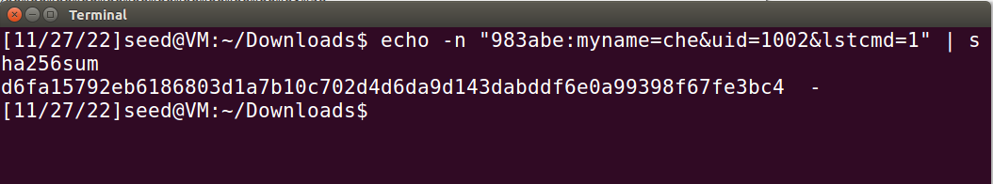

We are able to access the directory:

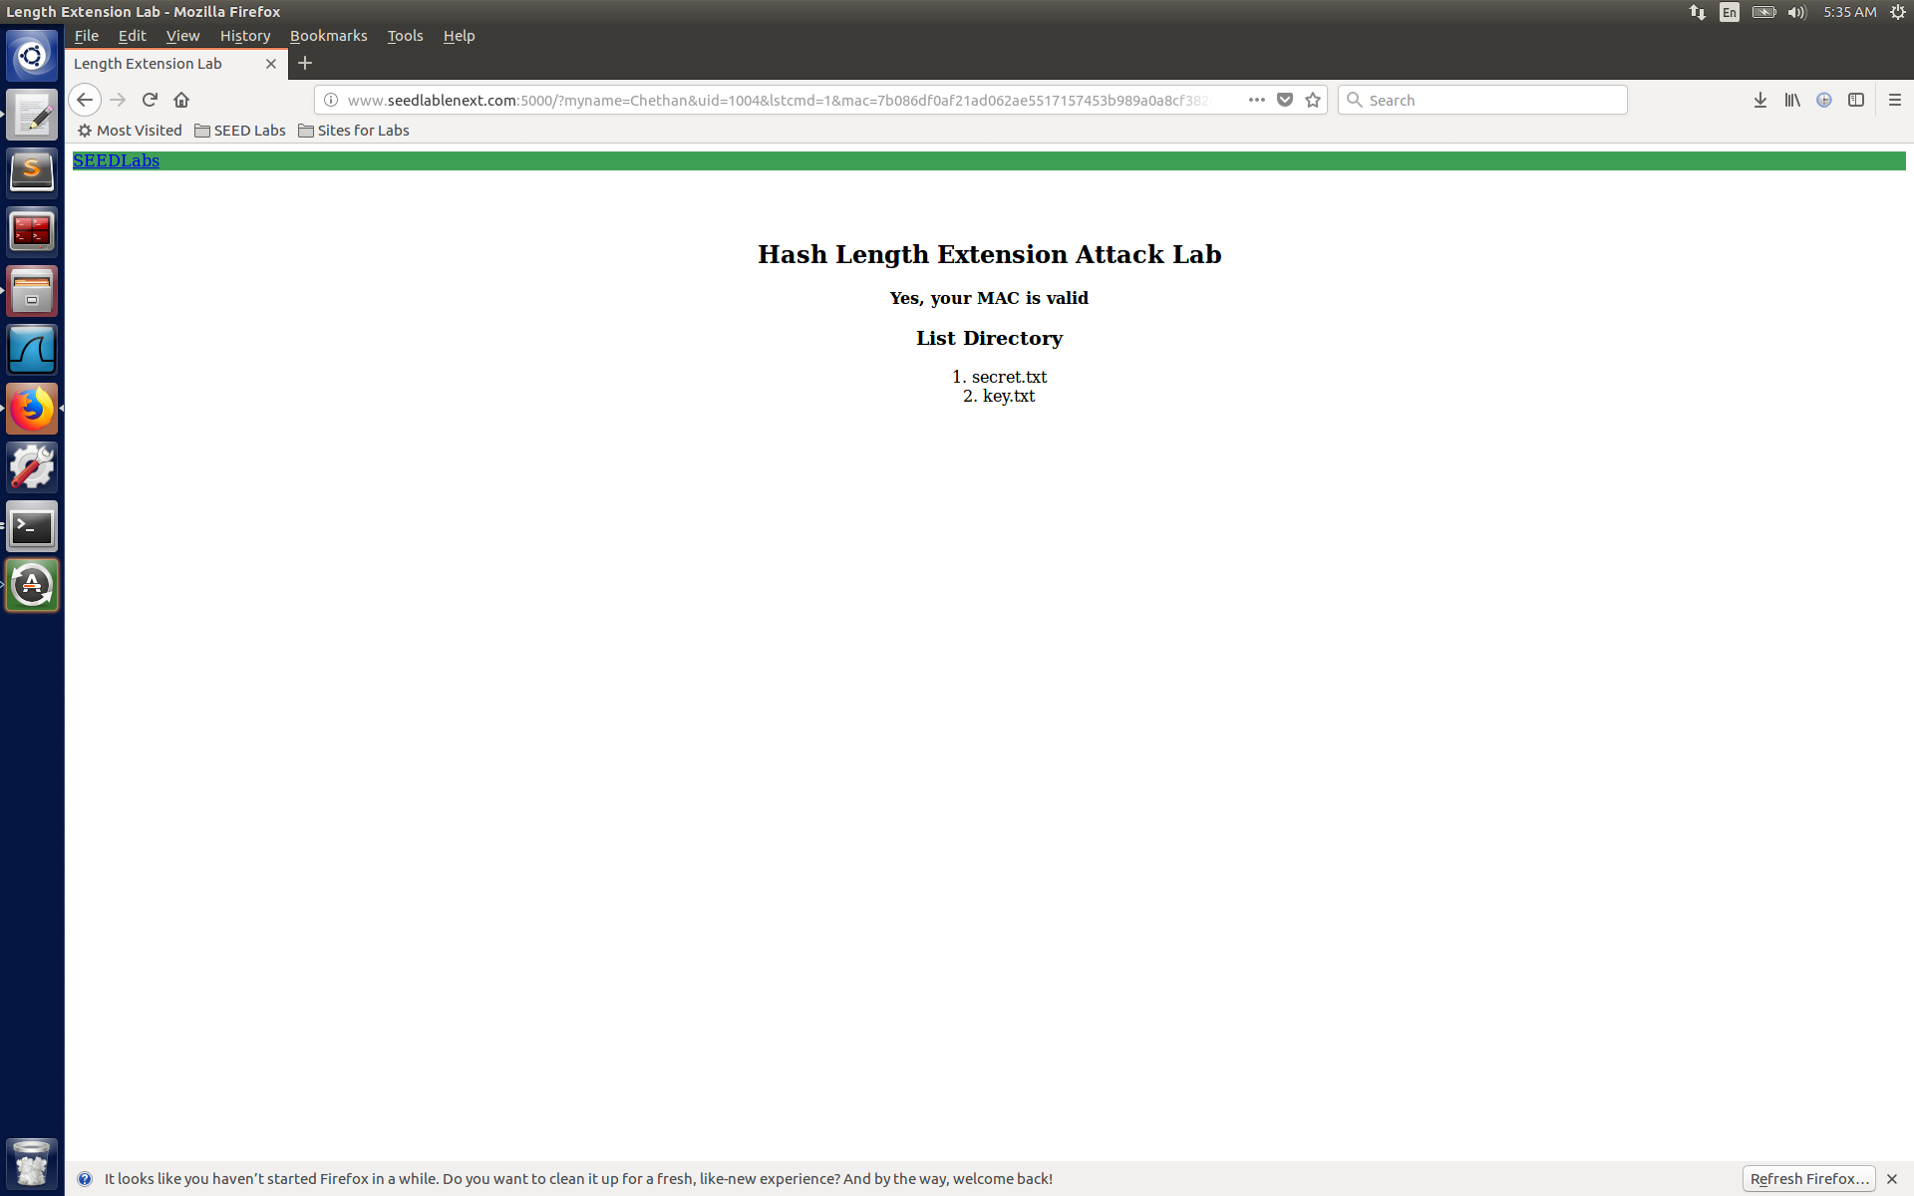

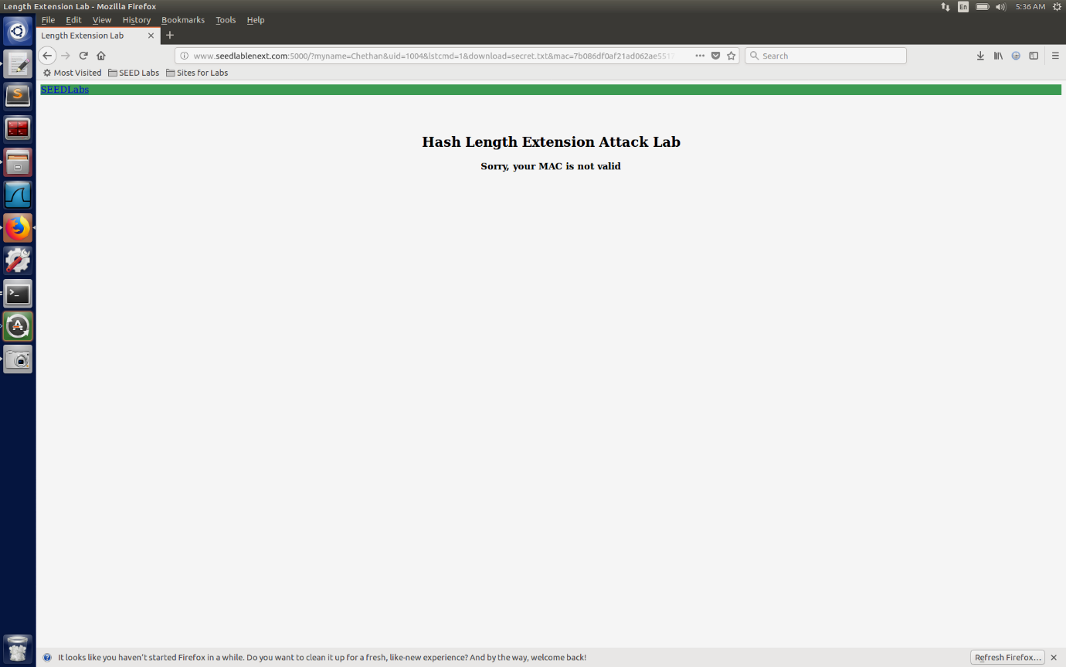

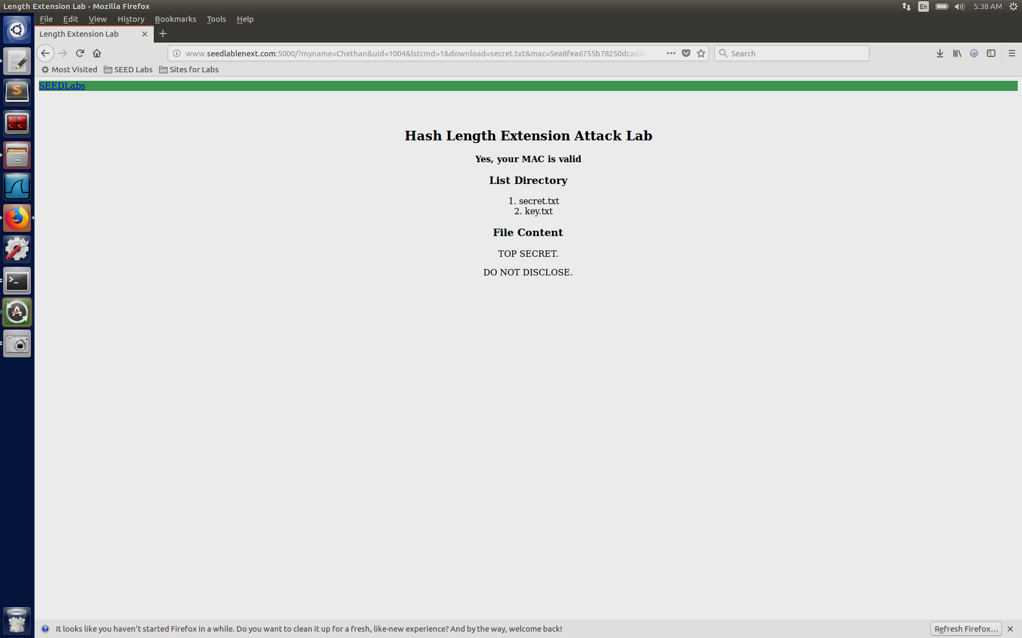

TASK-2 Create Padding

Creating pad using python :

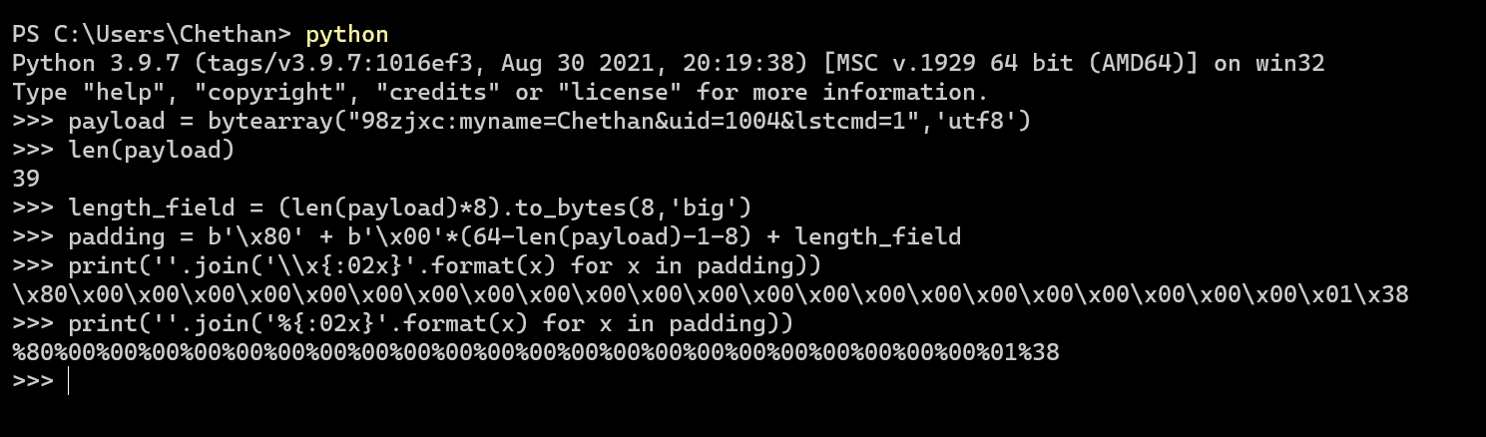

% representation for the url encoding.

TASK-3 Compute MAC using Key

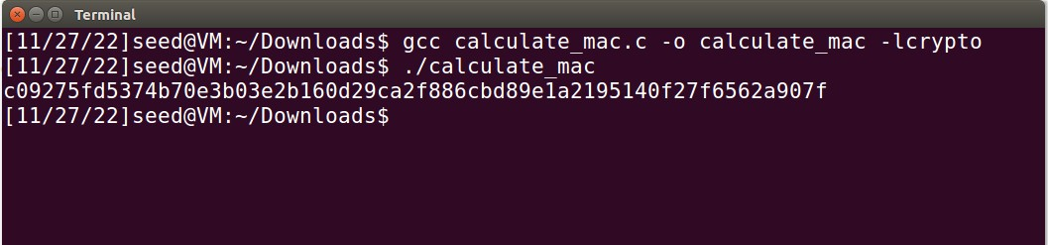

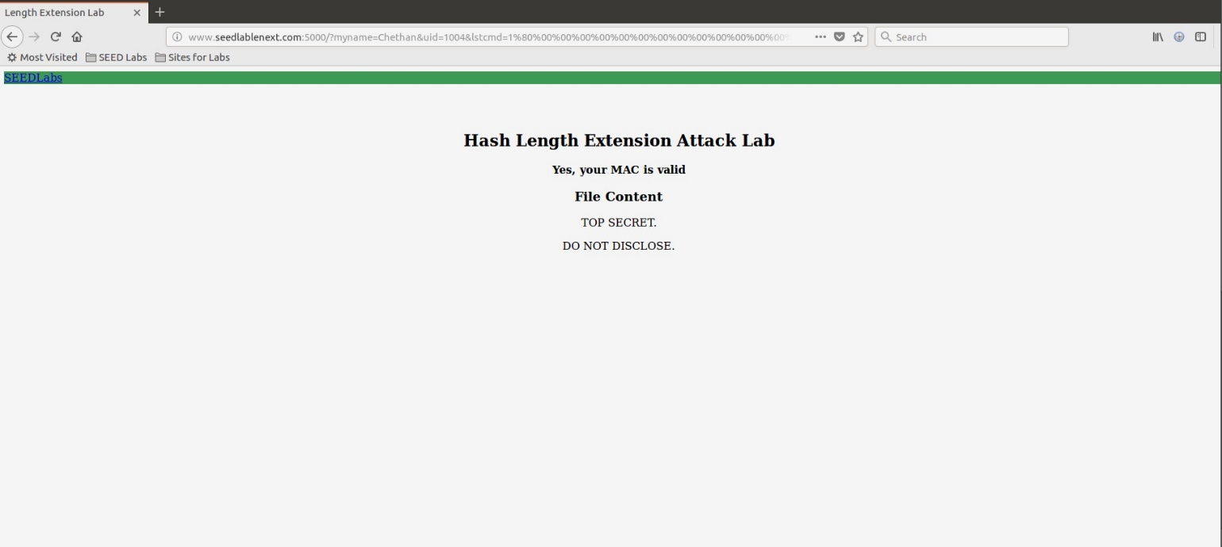

We are able to see the contents using calculated MAC.

TASK-4 Length extension attack

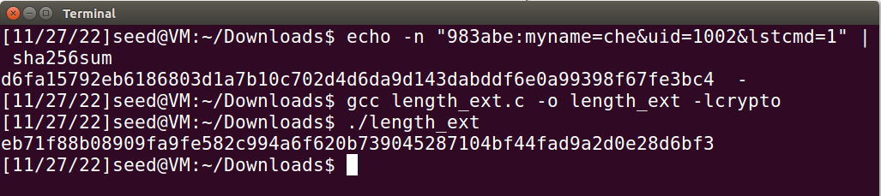

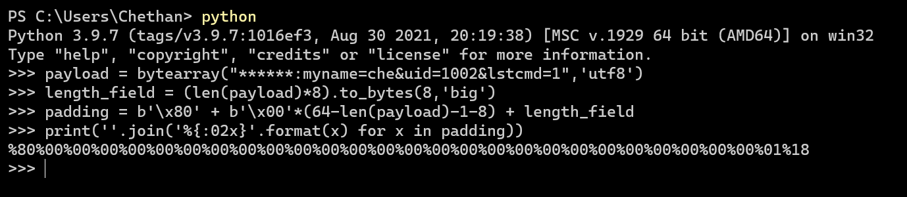



TASK-5 Attack Mitigation

Calculating HMAC:

